 

Umm Al Qura University

College of Engineering and Computers in Al-Qunfudhah

Department of Computer Science

" Software Documentation and Technical Writing"

**“HUNGER STATION”**

| Name | ID |
| --- | --- |
| Amjad Alfalahi | 444000591 |
| Layla Alshiki | 444002579 |

Dr.Mona Alofi

**1. Introduction:** **3**

**Chapter 1** **4**

2.1 Introduction: 4

2.2 HungerStation App Requirements: 4

2.3 HungerStation App Task: 5

2.4 Conclusion: 6

**Chapter 2** **7**

3.1 Introduction: 7

3.2 Purpose Of The App : 7

3.3 Survey on the need for delivery apps : 8

3.4 Similar Applications: 11

3.5 Conclusion: 12

**Chapter 3** **13**

4.1 Introduction: 13

4.2 Application design : 14

4.2.1 Sytstem Architecture : 14

4.2.2 Data model: 15

4.3.1 Efficiency and Performance: 16

4..1.3.2 ‎Technologies used: 16

4.1.3.3 ‎Application Development: 16

4.1.3.4 ‎Security: 16

‎4.1.3.5 Additional Features: 16

4.5 Version control : 17

4.3 Conclusion chapter 3 : 17

**5.Conclusion:** **18**

**6. Reference :** **19**

# 1. Introduction:

The Kingdom of Saudi Arabia is one of the most prominent countries witnessing remarkable growth in the field of e-commerce in the Arab world. This growth is due to the efforts of the Kingdom of Saudi Arabia to enhance commercial activity and provide distinguished services to entrepreneurs and emerging companies.

‎Its role is not limited to that only, but it is also distinguished by launching platforms to develop online stores and facilitate digital marketing.

‎With the increasing demand for online shopping, delivery applications have spread widely throughout the Kingdom, covering most cities and regions. This spread is due to the reliance of many individuals on the Internet to meet their daily needs. These applications save users time and effort, in addition to providing attractive prices and offers and a variety of products to meet their needs perfectly.

HungerStation is one of the most popular delivery applications in the Middle East. It operates in the Kingdom of Saudi Arabia and Bahrain. It mainly relies on displaying food products or various goods provided by merchants through the application, so that the customer orders these products or goods through these stores available in the application, and they are delivered to the customer by a delivery team dedicated to the application.

The customer can track the order and communicate with the delivery employee as well. He can also cancel the order or modify the order and specify the delivery time and many of the powers available to him.

# 

# 

# Chapter 1

## 2.1 Introduction:

There must be functional and non-functional requirements to understand the program to be described and implemented.

Functional requirements help in analyzing and identifying functions, while the advantage of non-functional requirements is that they help you ensure a good user experience.

Also, the presence of tasks for the application helps in understanding the advantages of the application that distinguish it from others.

## 2.2 HungerStation App Requirements:

**2.2.1 Functional Requirements:**

**2.2.1.1 Login:** Users must be able to register, log in and log out.

**2.2.1.2. Communication:** The system must have a page to communicate with the restaurant or the delivery representative.

**2.2.1.3. Search function:** Users can search for specific data or items.

**2.2.1.4. Notifications:** Send alerts or notifications to users.

**2.2.1.5. Evaluation:** A page to evaluate the restaurant and the representative, and also to evaluate the application.

**2.2.2 Non-functional requirements:**

**2.2.2.1. Performance:** The system must handle many users at the same time.

**2.2.2.2. Security:** Data encryption and secure access protocols must be implemented.

**2.2.2.3. Ease of use:** The interface must be intuitive and easy to navigate for all users.

**2.2.2.4. Reliability:** The system uptime must be at least 99.9% over the course of a year.

## 

## 2.3 HungerStation App Task:

**2.3.1. Location:**

Enter the delivery address or multiple addresses.

**2.3.2 Payment:**

Various payment options(card, cash, Tabby, Tamara).

**2.3.3 Order tracking:**

Follow the order status or arrival time.

**2.3.4 Technical support:**

Contact customer service to solve problems.

**2.3.5 Account management:**

Update personal information and payment methods.

## 2.4 Conclusion:

HungerStation app requirements include a set of basic functions such as logging in, communicating with restaurants, searching for items, and sending notifications.

They also include rating the services provided.

On the non-functional side, the app should have high performance, strong security, ease of use, and high reliability.

Additionally, the app requires features such as entering a delivery address, multiple payment options, order tracking, technical support, and account management.

These requirements ensure a great and efficient user experience.

# Chapter 2

## 3.1 Introduction:

To identify the disadvantages and advantages of delivery applications, and users' opinions about them, and based on their answers, we identify the problems and suggest solutions for them and the results of these solutions. Developing delivery applications and making them more efficient solves the problem of difficulty in accessing services and purchasing some food items by facilitating and organizing communication between delivery officials and the customer.

Now you can order what you want while you are at home or at your workplace and your order will reach you at a specific time without the need to go and buy

## 

## 3.2 Purpose Of The App :

Addressing the problem of difficulty in accessing services and purchasing some food supplies by facilitating and organizing communication between delivery officials and customer .

And solving the problem of payment methods and traffic congestion, as you can order what you want while you are at your home or workplace and your order will reach you at a specific time without the need to go and buy. Where you can now buy what you can and request delivery of what you want anywhere .

## 3.3 Survey on the need for delivery apps :

A survey was conducted and opinions were collected about the need for delivery apps, their importance, and how to use or improve them

* **We asked these questions to a number of people :**

**Q1.** Do you use delivery apps?

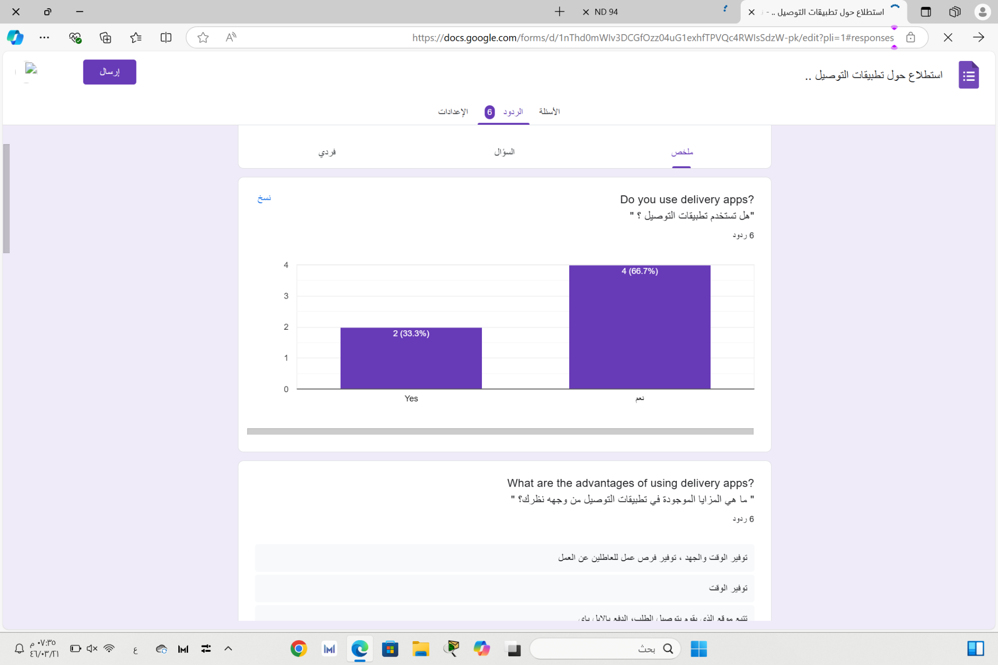

**Q2.** What are the advantages of using delivery apps?

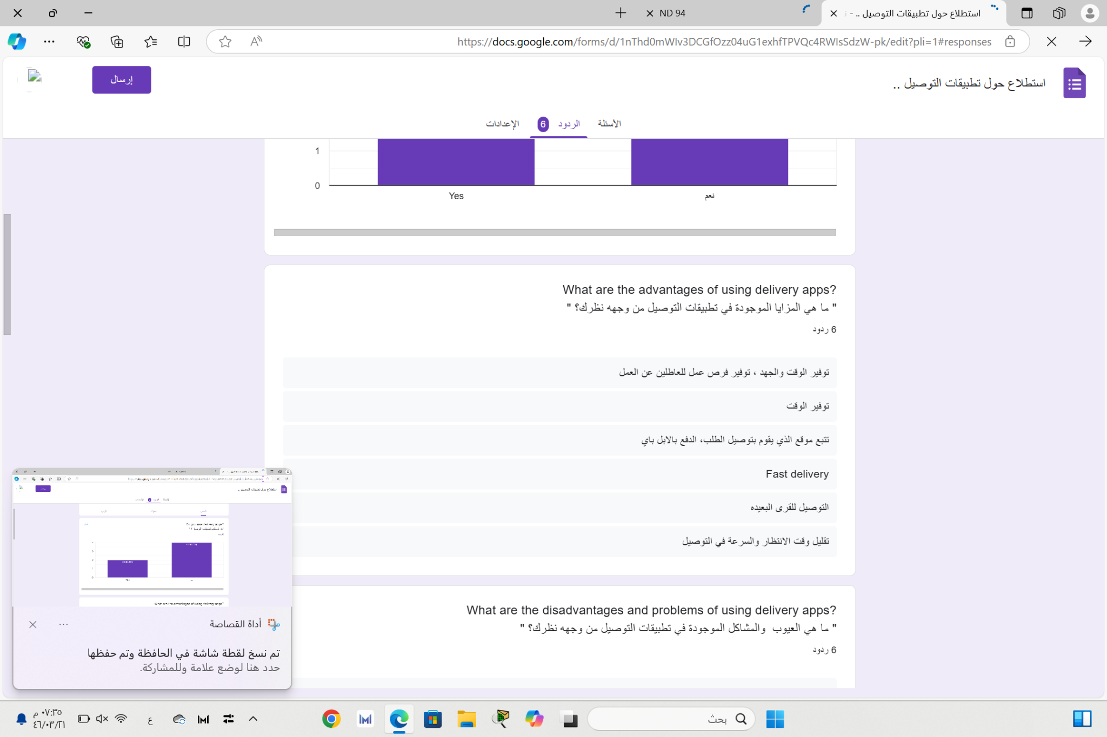

**Q3.** In your opinion, what is the appropriate duration for an

order to arrive?

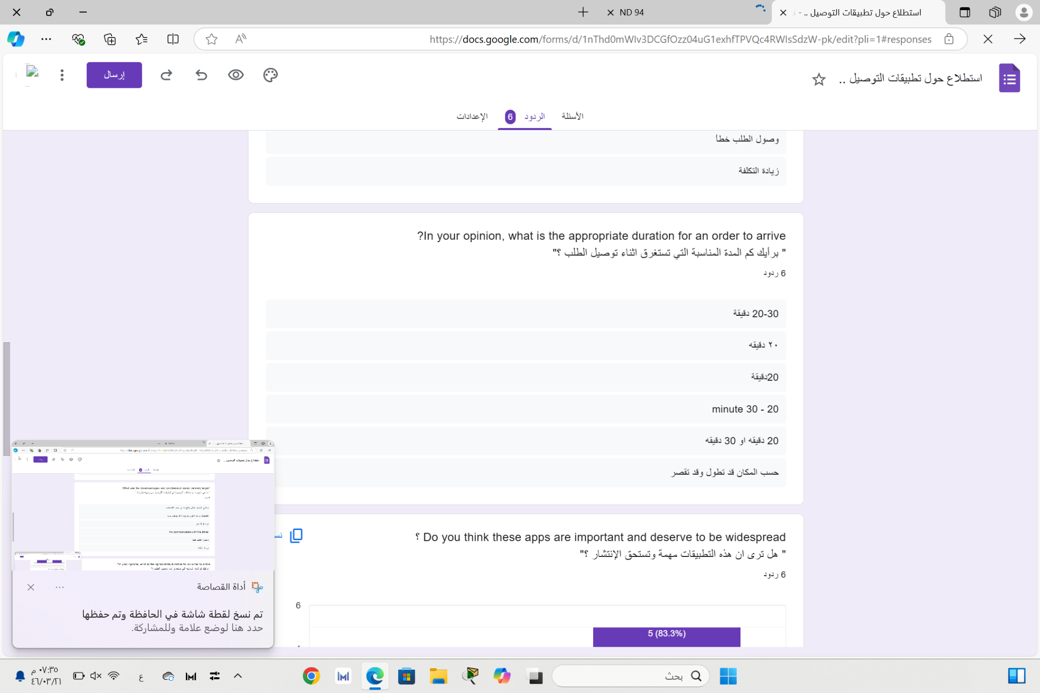

**Q4.** Do you think these apps are important and deserve to be widespread?

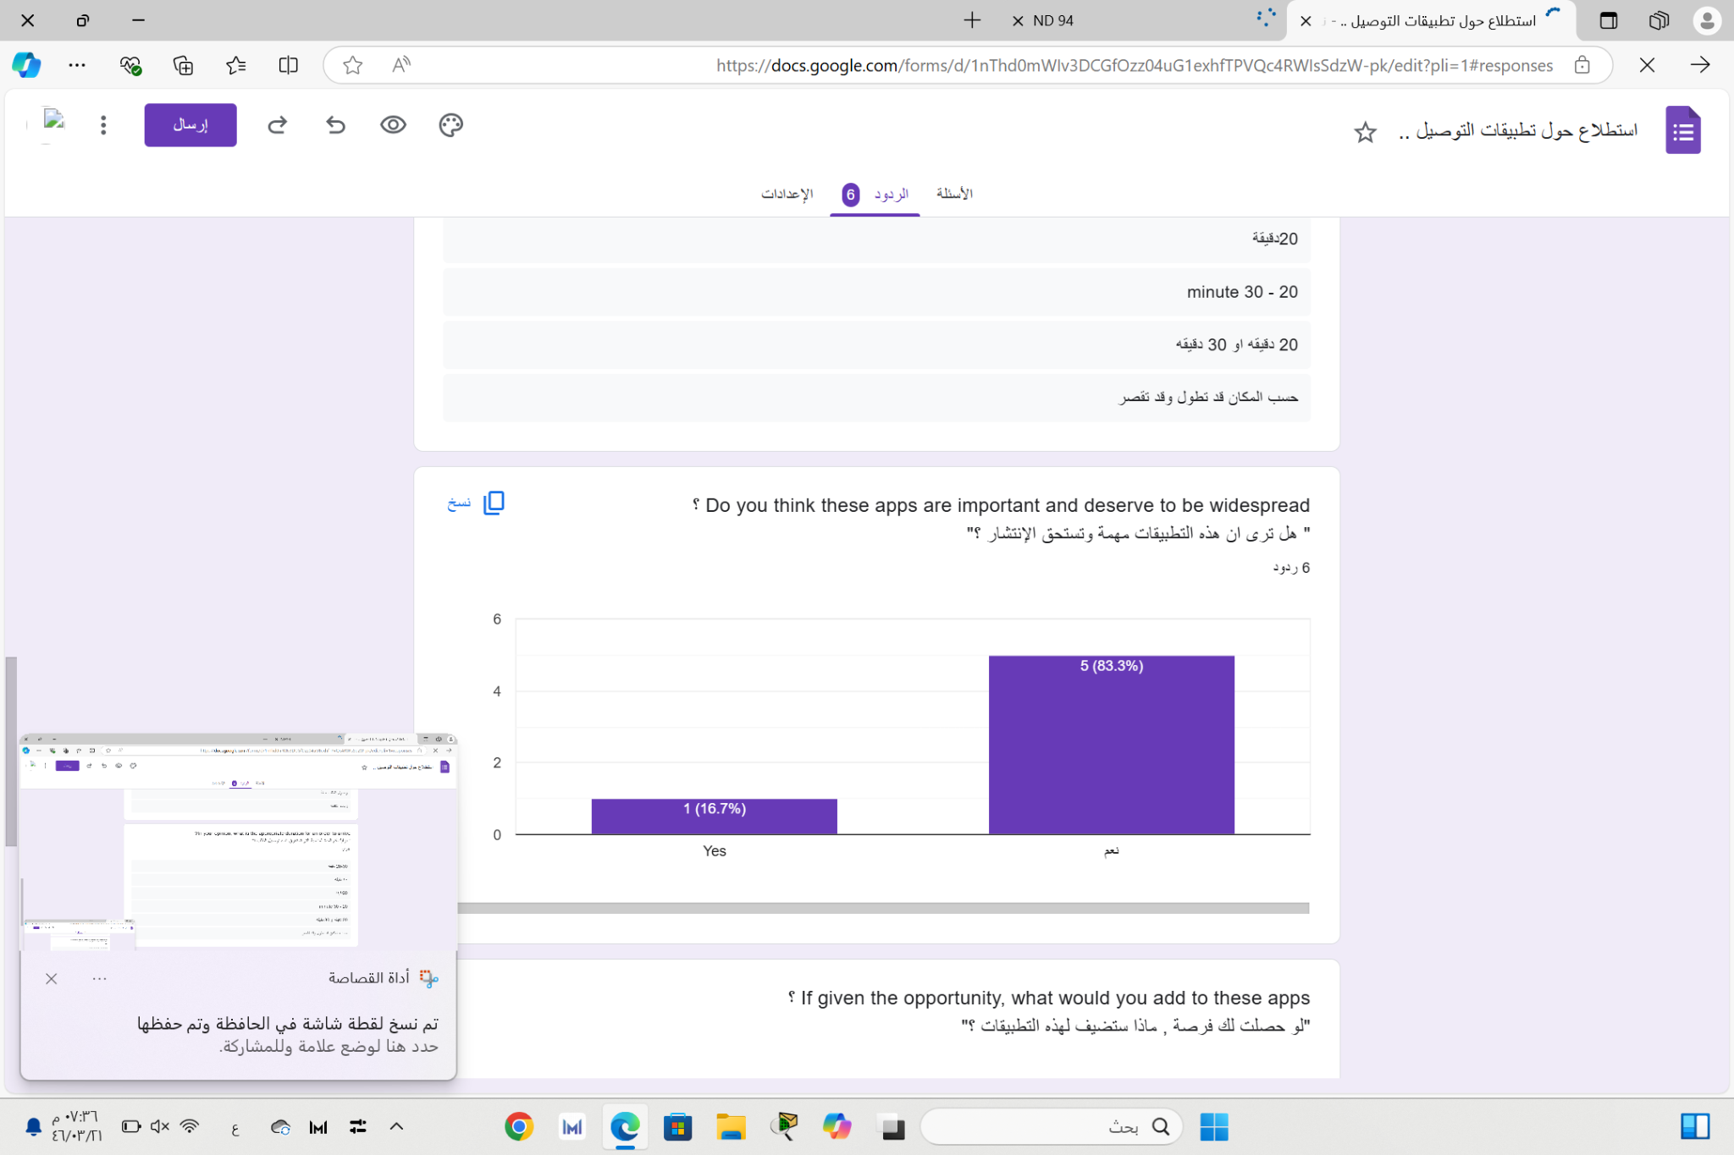

**Q5.** If given the opportunity, what would you add to these apps?

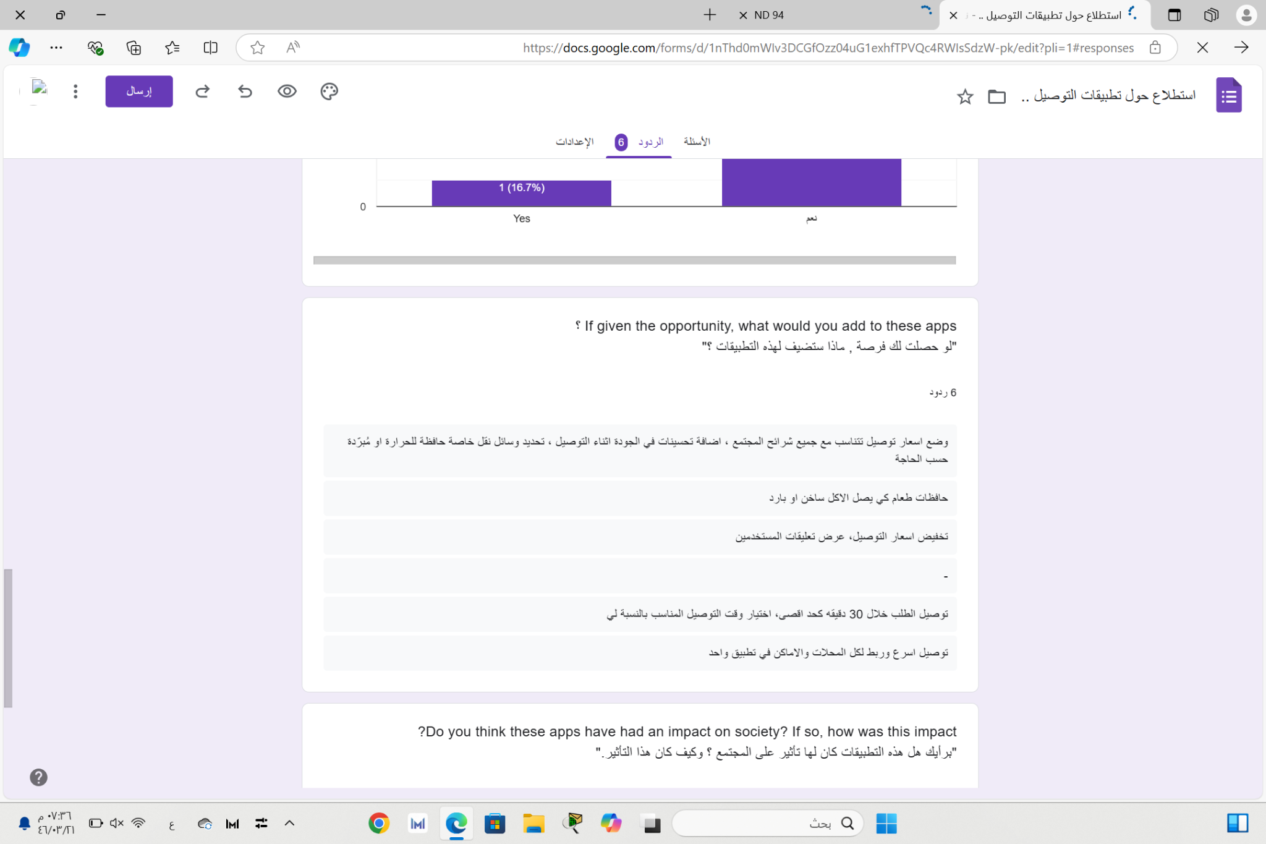

**Q6.** Do you think these apps have had an impact on society?

If so, how was this impact?

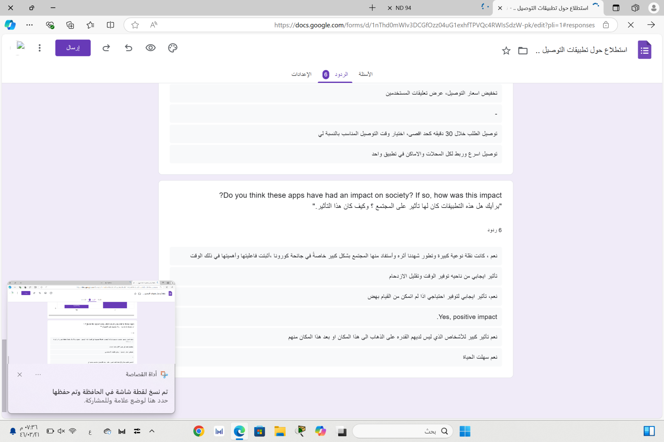

**Q7.** What are the disadvantages and problems of using delivery

apps ?

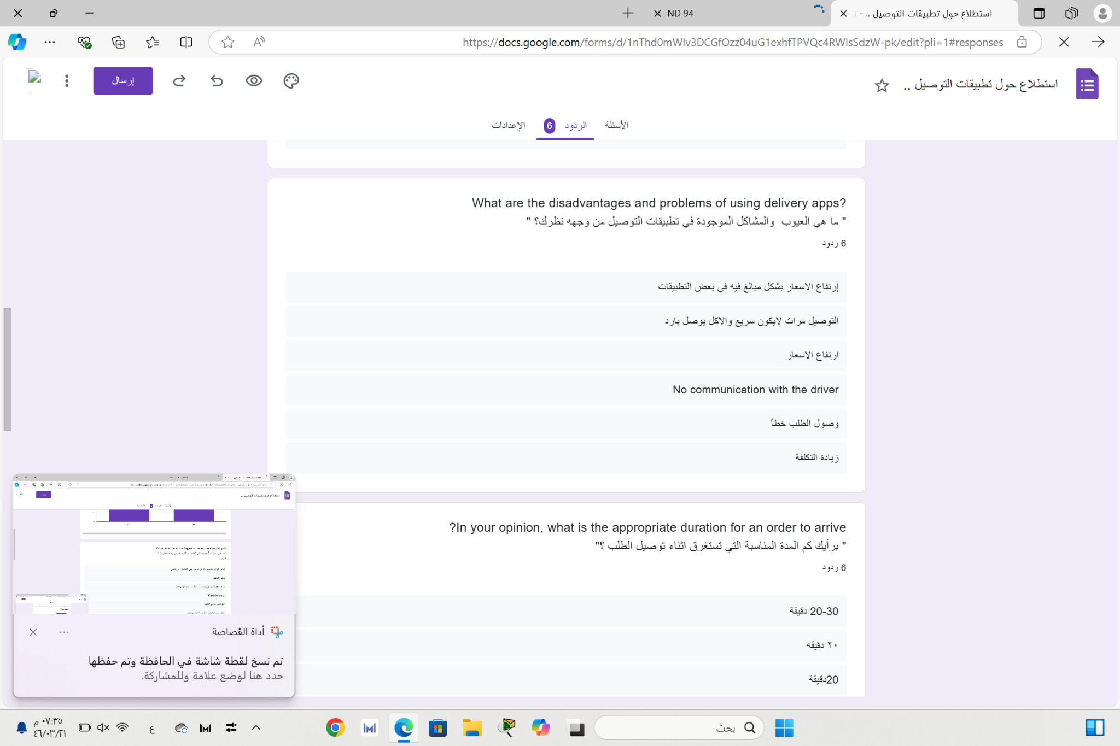

100% of those who answered this survey indicated that they use delivery apps.

They mentioned advantages such as time and effort savings, additional job opportunities, order tracking, multiple payment methods like Apple Pay, delivery to remote areas, reduced waiting time, and fast delivery.

Disadvantages included excessively high prices, occasional delays in delivery, receiving cold or poor-quality food, and increased costs. Supporters believed these apps deserve more popularity than those who oppose the idea.

The ideal delivery time was suggested to be 30 minutes or a minimum of 20 minutes.

Suggestions for improvements included setting delivery prices suitable for the community, enhancing delivery quality, using food containers for intact and quality food delivery, displaying user reviews, delivering orders within 30 minutes maximum, choosing suitable delivery times for individuals, and integrating all stores and locations into one app.

Respondents believed these apps had a significant positive impact on society during the COVID-19 pandemic by saving time and reducing congestion.

**There are also some problems that currently exist in delivery applications:**

"Delayed delivery" The solution is to set a reasonable delivery time according to the distance

Putting a financial reward for the delivery official (driver) when delivering at the specified time"

"High prices" The solution is a monthly subscription for a symbolic amount and an unlimited request

"Incorrect or incomplete order" The solution is a chat page "Communicate" the customer with the restaurant or supermarket before completing the order completely to ensure the availability

## 

## 3**.**4 **Similar Applications:**

There are similar applications to the one we discussed, such as

Jahez, Mr.mandoob, and Mrsool.

|  | **Advantages:** | **Disadvantages:** |
| --- | --- | --- |
| **Jahez:** | **- Simple and easy user interface.**  **- Multiple restaurant options.**  **- Support for large orders.** | **- Prices may be high.**  **- Delay in delivery of orders sometimes.** |
| **Mr.mandoob:** | **- Focus on fast delivery.**  **- Varied store options.** | **- Limited in some areas.**  **- Users may encounter problems with customer service.** |
| **Mrsool:** | **- Ability to deliver any product, not just food.**  **- Good rating system for drivers** | **- Fees may be high for some orders.**  **- Delay in delivery during peak times.** |

## 3.5 Conclusion:

After knowing the users' opinions and understanding the disadvantages, advantages and problems, it became easy to find solutions to these problems.

When we put "a financial reward for the delivery person (driver) when delivering on time" to reduce delivery delays, the keenness and productivity of delivery people increased.

When putting monthly offers and subscriptions for a symbolic amount, the problem of high prices for each order was solved, and the number of users of the application increased.

The chat page "Contact" the customer with the restaurant or supermarket before completing the order completely has a great impact on the quality of the service provided, as the customer can easily confirm, modify or cancel an order and also make sure that the products are available before paying and confirming the order.

# 

# Chapter 3

## 4.1 Introduction:

In this section, we will review the class diagram that illustrates the application’s structure and how objects interact with each other.

Efficiency and performance will be discussed in relation to the application’s architectural design, and how to improve response speed and utilize resources effectively.

We will also highlight the technologies used in building the system, whether on the front-end or the server and database side, to ensure a smooth and reliable user experience.

Finally, we will discuss the security aspect and how to implement the necessary protection standards to preserve data and ensure confidentiality of information.

## 4.2 Application design :

### 4.2.1 Sytstem Architecture :

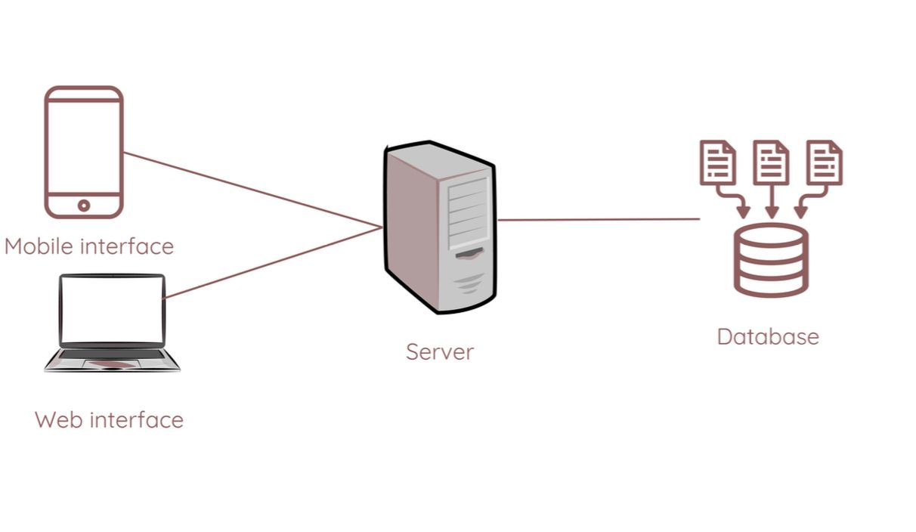

Figure 4.2.1 represents the technical structure of the system:

1. Mobile interface and Web interface: refer to the ways in which the user interacts with the app either via mobile or through the website.

2. Server: Both the phone and web interfaces connect to the server which acts as an intermediary between the user and the data.

3. Database: The server communicates with the database, where all the information such as user data, orders, and restaurants are stored.

This system shows how the interfaces interact with the server and database to ensure smooth service to the user.

### 4.2.2 Data model:

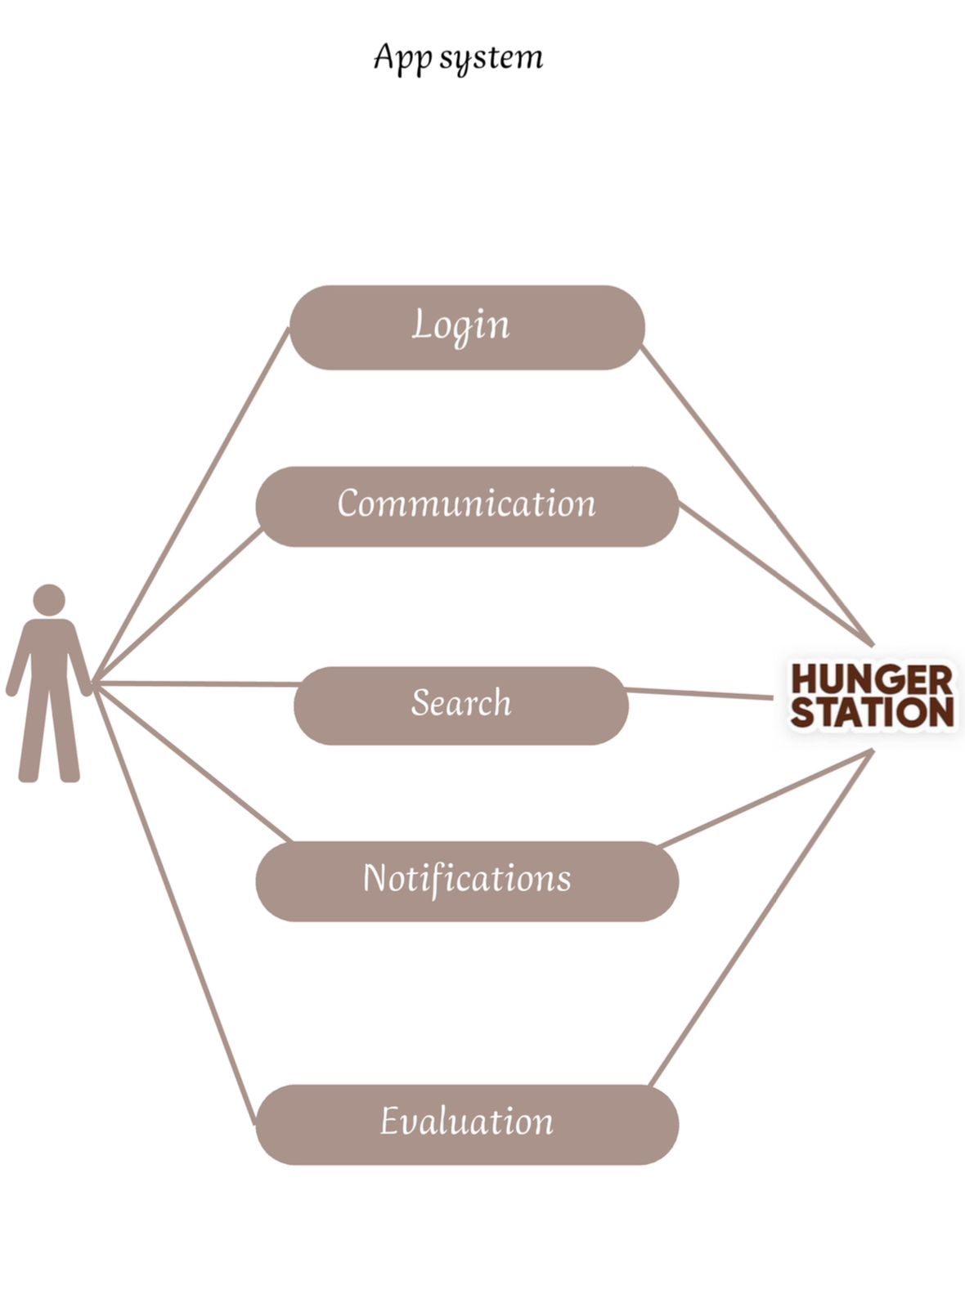

Figure 4.2.2 illustrates a system for a delivery app like HungerStation

The system consists of several elements related to the user:

1. Login: where the user starts accessing the app.

2. Communication: part of the system that refers to the possibility of communication within the app, perhaps between the user and the restaurants or the support team.

3. Search: the user can search for restaurants or products within the app.

4. Notifications: the system provides the user with notifications related to requests or offers.

5. Evaluation: after use, the user can evaluate the service or products.

All of these elements are related to the HungerStation app, which means that this is the system that the app uses to provide its services.

**4.2.3 Technical Specifications:**

HungerStation App Technical Specifications

4.2.3.1 Efficiency and Performance:

* Random Access Memory (RAM): Minimum 4 GB, preferably 8 GB.

* Database: NoSQL database (such as MongoDB) or SQL-based (such as MySQL/PostgreSQL), with a capacity starting from 20 to 50 GB, with scalable cloud storage solutions (such as AWS or Google Cloud).

* Caching: Using Redis or Memcached to improve response time.

* Response time: Less than 2 seconds for most operations.

* Scalability: Support up to 1 million active users at the same time.

4.2.3.2 Technologies Used:

* Front-end: Swift for iOS, Kotlin for Android, React.js or Angular.js for web.

* Back-end: Python with Django or Flask framework, APIs using GraphQL, microservices architecture.

* Cloud Infrastructure: AWS or Google Cloud for hosting and scaling.

4.2.3.3 Security:

* Authentication: OAuth 2.0, integration with Nafath platform, and two-factor authentication (2FA).

* Session management: Using secure JWT tokens.

* Data encryption: Full encryption (AES-256).

* Compliance: Compliance with PCI-DSS standards for financial transaction security.

* Testing: Regular vulnerability scans and penetration tests.

4.2.3.4 Additional features:

* Order tracking: Real-time updates via Google Maps API.

* Live chat: Communicate via WebSocket with restaurants or technical support.

* Notifications: Instant alerts using Firebase Cloud Messaging (FCM).

* Payment methods: Credit cards, Apple Pay, Mada, Tabby, and Tamara.

4.2.3.5 Reliability:

* Uptime: Guaranteed uptime of up to 99.9% using load balancing and failover strategies.

* Disaster recovery: Cloud backup solutions and a one-hour system recovery plan in case of a failure.

These specifications ensure high performance, scalability, and security for the HungerStation app in Saudi Arabia and Bahrain

## 4.5 Version control :

## 4.3 Conclusion chapter 3 :

In conclusion, the data model and system design demonstrate high efficiency in managing operations and achieving optimal performance through modern technologies that ensure rapid response and good utilization of resources. The system also reflects strict adherence to security standards, which enhances confidence in data protection and information confidentiality. Based on these factors, we can say that the integrated design of the application provides a distinct and secure user experience that meets needs with high efficiency.

# 5.Conclusion:

delivery applications have become an essential part of people's daily lives, making it easy for users to access various services and products quickly and easily. These applications represent a qualitative shift in the world of commerce, as they rely on advanced technologies to ensure efficient performance and a comfortable user experience. In addition, these applications provide a high level of security, whether in terms of protecting personal data or financial transactions. With the continuous development in this field, the importance of these applications is expected to increase in the future, contributing to improving the level of comfort and meeting the needs of consumers better and faster. We can say that our role and attempts in developing the application were for the purpose of improving the user experience and ensuring efficient performance. By working on improving the structural design of the application, and providing effective solutions that better meet the needs of users. It also focused on improving the performance and stability of the application, ensuring a smooth and reliable experience. This role was not only in the technical aspects, but also included understanding the needs of the market and users to ensure the provision of a product that meets their aspirations and keeps pace with the continuous developments in the field of technology

# 6. Reference :

- Food delivery platforms report from OCEANX, a Saudi consulting company established in 2012, provides consulting services to the public and private sectors.